**Project Title**

Grain palette-A Deep Learning Odyssey In Rice Type Classification Through Transfer Learning

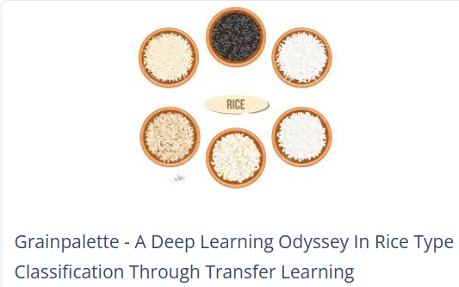

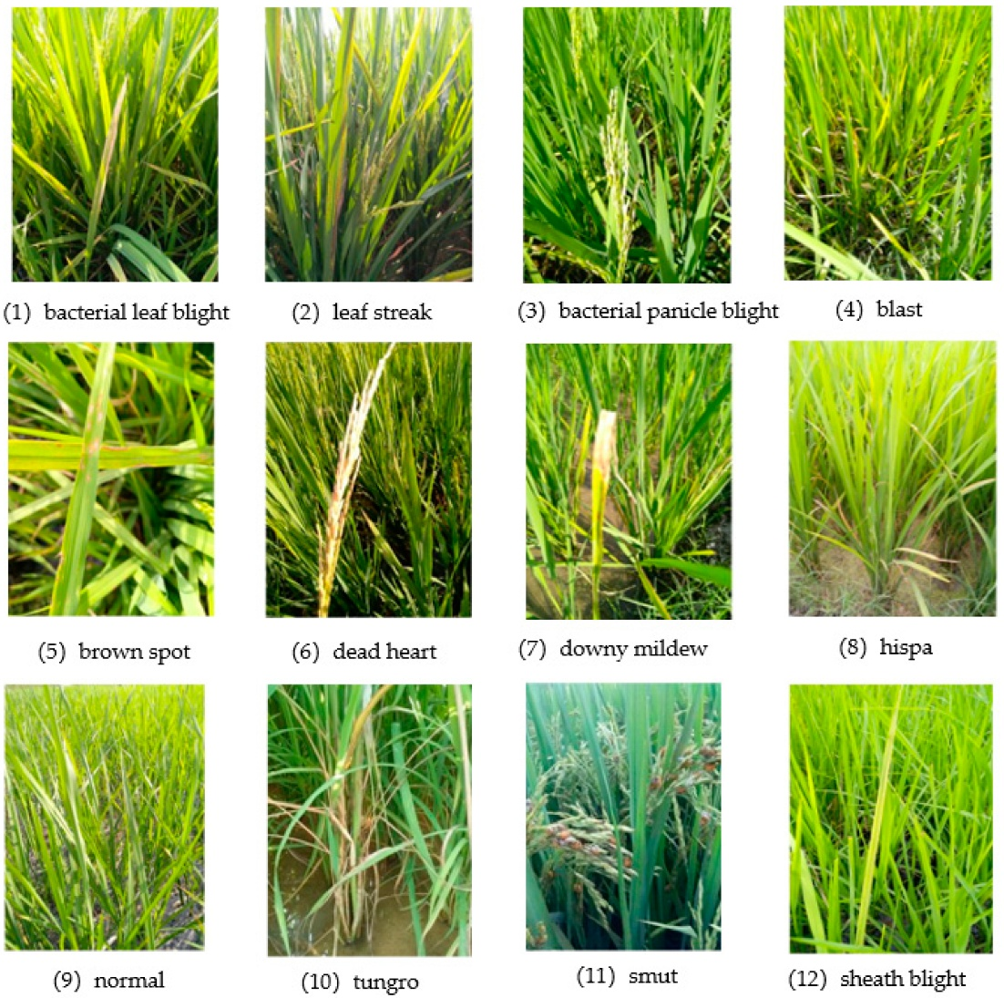

**Introduction:**

Here's a potential introduction for your project titled **"GrainPalette – A Deep Learning Odyssey in Rice Type Classification Through Transfer Learning"**:

In an era where precision agriculture is reshaping food production, **GrainPalette** emerges as a novel deep learning-powered solution for rice type classification. Leveraging the power of transfer learning, this project ventures beyond traditional image classification by applying state-of-the-art convolutional neural networks to a real-world agricultural challenge. Accurate identification of rice varieties plays a critical role in ensuring grain quality, optimizing supply chains, and assisting farmers and traders in making informed decisions. However, the visual similarity between different rice types often renders manual classification unreliable and time-consuming.

This project harnesses pre-trained neural architectures, fine-tuned specifically for rice grain imagery, to drastically enhance classification performance with limited data. From curating a diverse dataset and training robust models, to building a practical user interface for seamless interaction, **GrainPalette** represents an end-to-end journey that blends technical rigor with meaningful application.

**Architecture:**

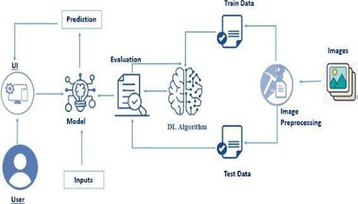

**System Workflow Overview**

Here’s a clear and structured **System Workflow Overview** for your *GrainPalette* project:

**🌾 GrainPalette System Workflow Overview**

**1. Data Acquisition & Preprocessing**

* **Input:** High-resolution images of different rice varieties.
* **Steps:**
  + Collect images from reliable sources or through manual image capture.
  + Label and organize images by rice type.
  + Preprocess: resize, normalize, augment (rotation, zoom, flip) to improve model robustness.

**2. Transfer Learning Model Architecture**

* **Model:** Pre-trained CNN (e.g., EfficientNet, MobileNetV2, or ResNet50).
* **Steps:**
  + Load the base model with ImageNet weights.
  + Freeze initial layers; attach custom classification head.
  + Compile with appropriate optimizer and loss function (e.g., Adam + categorical crossentropy).

**3. Training & Fine-Tuning**

* **Input:** Augmented training and validation datasets.
* **Steps:**
  + Train the model initially with frozen base layers.
  + Unfreeze top layers and fine-tune with a low learning rate.
  + Monitor metrics (accuracy, loss) and apply early stopping/checkpointing.

**4. Evaluation & Testing**

* **Steps:**
  + Evaluate performance on unseen test data.
  + Generate classification report, confusion matrix, and accuracy graphs.
  + Perform error analysis to understand misclassifications.

**5. User Interface Integration**

* **Frontend:** HTML/CSS for styling, possibly with a lightweight JS framework.
* **Backend:** Python with Flask or FastAPI to handle model inference.
* **Steps:**
  + Upload image → Process → Predict rice type → Display result.

**6. Deployment**

* **Options:** Deploy locally, on cloud (e.g., Heroku, Render, Azure), or as a desktop app.
* **Steps:**
  + Containerize (optional) using Docker.
  + Package the model and UI for smooth user experience.
  + Test performance in real-world scenarios.

**Prerequisites**

**Here’s a concise list of prerequisites for developing your *GrainPalette* project — tailored for your skill set and the nature of the task:**

**✅ Technical Prerequisites**

**1. Programming Knowledge**

* **Proficiency in Python, particularly libraries like TensorFlow/Keras or PyTorch.**
* **Familiarity with HTML/CSS for front-end development.**
* **Basics of Flask or FastAPI for setting up a lightweight backend.**

**2. Machine Learning & Deep Learning**

* **Strong grasp of CNNs and transfer learning principles.**
* **Understanding of data preprocessing, model fine-tuning, and evaluation metrics.**

**3. Tools & Frameworks**

* **Jupyter Notebook or an IDE like VSCode or PyCharm.**
* **Libraries: NumPy, Pandas, Matplotlib, Scikit-learn for data handling and visualization.**
* **TensorFlow Hub or Keras Applications for pre-trained models.**

**4. Dataset Preparation**

* **Access to a labeled dataset of rice grain images.**
* **Image preprocessing knowledge: resizing, normalization, augmentation.**

**5. Deployment Readiness**

* **Basic understanding of deploying models on platforms like Heroku, Render, or locally.**
* **Optional: Familiarity with Docker for containerization.**

**🔧 Hardware & Software Requirements**

* **A machine with a GPU (or access to cloud resources like Google Colab or Kaggle).**
* **Python 3.7+ environment with all dependencies installed via pip or conda.**

**Project Objectives**

**Absolutely! Here’s a structured outline of the Project Objectives for your *GrainPalette* rice type classification project:**

**🎯 Project Objectives of GrainPalette**

**1. Develop an Accurate Classification Model  
Utilize transfer learning with state-of-the-art CNN architectures to build a model capable of accurately classifying multiple rice varieties based on visual characteristics.**

**2. Apply Transfer Learning for Data Efficiency  
Leverage pre-trained models to minimize the requirement for large-scale training datasets and reduce model development time while maintaining high performance.**

**3. Ensure Robustness Through Augmentation  
Implement a diverse set of image preprocessing and augmentation techniques to improve the model’s ability to generalize across different image qualities and conditions.**

**4. Build an Intuitive User Interface  
Design and integrate a user-friendly web interface that allows users to upload rice grain images and receive classification results in real time.**

**5. Facilitate Real-World Applicability  
Focus on practical deployment strategies—cloud hosting, local apps, or mobile-ready solutions—to make GrainPalette usable by farmers, traders, or agricultural analysts.**

**6. Analyze Performance and Optimize Model  
Continuously monitor classification accuracy, interpret confusion matrices, and refine the model through fine-tuning and hyperparameter adjustments.**

**7. Promote Smart Agriculture Practices  
Support agricultural decision-making by providing a reliable digital tool that enhances efficiency in rice identification and quality control.**

**Project Flow:**

* Here’s a well-structured **Project Flow** for your *GrainPalette* deep learning-based rice classification system, capturing the end-to-end development pipeline:
* **🌾 GrainPalette — Project Flow**
* **1. Define Problem & Set Objectives**  
  Clearly articulate the classification challenge, determine the number of rice varieties, and outline performance goals for accuracy and usability.
* **2. Dataset Curation & Preprocessing**
* Acquire and label rice grain images.
* Perform preprocessing: resize, normalize, augment (e.g., rotate, flip, contrast).
* Split into training, validation, and test sets.
* **3. Model Selection & Transfer Learning Setup**
* Choose a pre-trained model (e.g., MobileNetV2, ResNet50, EfficientNet).
* Replace top layers with a custom classifier.
* Freeze base layers and compile with chosen optimizer and loss function.
* **4. Training & Validation**
* Train the model using augmented data.
* Track metrics (accuracy, loss) and implement callbacks (early stopping, checkpointing).
* Gradually unfreeze layers and fine-tune with a lower learning rate.
* **5. Model Evaluation**
* Test model performance on unseen images.
* Visualize confusion matrix and classification report.
* Analyze misclassified samples for patterns.
* **6. Interface Development**
* Build the UI using HTML/CSS and optionally lightweight JavaScript.
* Set up backend using Flask or FastAPI to link model inference to user input.
* **7. Integration & Testing**
* Connect model to UI: user uploads → image processed → prediction returned.
* Conduct usability testing and optimize for responsiveness and efficiency.
* **8. Deployment**
* Package the app for local or cloud deployment (e.g., Render, Heroku, Azure).
* Optional: containerize with Docker for streamlined portability.
* **9. Documentation & Optimization**
* Document model architecture, training process, and usage instructions.
* Refine based on feedback or performance bottlenecks.

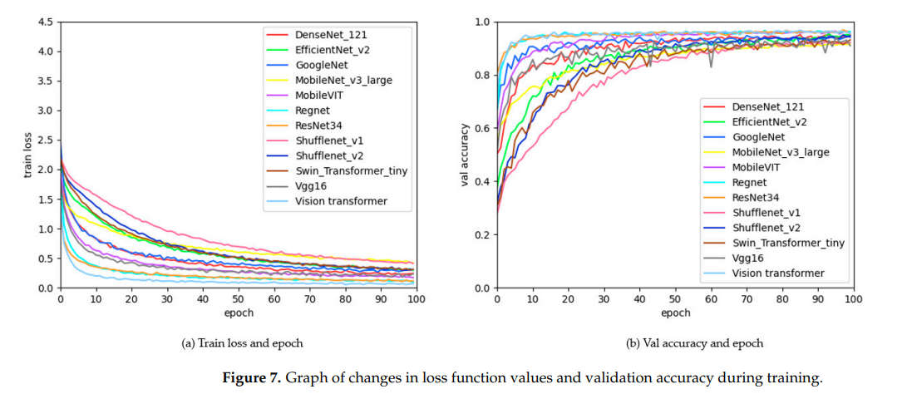

**Project Structure**

**Here’s a clean and modular Project Structure layout for your *GrainPalette* rice type classification system, designed to support scalability, readability, and easy integration of the frontend and backend components:**

**📁 GrainPalette/**

**├── 📂 data/**

**│ ├── raw/ # Original rice grain images**

**│ ├── processed/ # Preprocessed and augmented images**

**│ └── labels.csv # Metadata or labels for supervised learning**

**├── 📂 notebooks/**

**│ ├── data_preprocessing.ipynb**

**│ ├── model_training.ipynb**

**│ └── model_evaluation.ipynb**

**├── 📂 models/**

**│ ├── rice_classifier.h5 # Trained model weights**

**│ └── model_architecture.json**

**├── 📂 src/**

**│ ├── model.py # Model creation and fine-tuning code**

**│ ├── predict.py # Function for loading the model and making predictions**

**│ └── utils.py # Helper functions (e.g., image preprocessing)**

**├── 📂 static/**

**│ ├── css/ # Styling for frontend UI**

**│ └── images/ # Optional: UI assets or example images**

**├── 📂 templates/**

**│ └── index.html # HTML file rendered by Flask or FastAPI**

**├── 📂 app/**

**│ └── main.py # Backend entry point (Flask/FastAPI app)**

**├── requirements.txt # Python dependencies**

**├── Dockerfile # Optional: for containerization**

**└── README.md # Project overview and setup instructions**

**This structure separates your data processing, model logic, UI components, and deployment setup into their own well-defined compartments—ideal for collaboration or scaling later.**

**Data Collection and Preparation**

Here’s a detailed breakdown of the **Data Collection and Preparation** process for your *GrainPalette* rice classification system, tailored to ensure high-quality input for your deep learning model:

**🌾 Data Collection**

**1. Source Acquisition**

* **Public Datasets:** Search for open datasets like the Rice Leaf Disease dataset or crowd-sourced rice variety image repositories.
* **Manual Collection:** Capture high-resolution top-down images using a mobile camera or DSLR under consistent lighting conditions.
* **Diversity:** Include different rice types, lighting scenarios, grain orientations, and backgrounds to ensure model generalizability.

**2. Labeling**

* Assign correct labels to each image based on rice variety.
* Use a CSV file or folder-based structure (data/rice_type_name/image1.jpg) for easy parsing during training.

**🧹 Data Preparation**

**1. Cleaning**

* Remove blurry, duplicate, or mislabeled images.
* Ensure consistent image resolution or resize during preprocessing.

**2. Augmentation (Offline or On-the-fly)** To expand dataset diversity and minimize overfitting:

* **Transformations:** Rotation, flipping, zoom, contrast adjustment, brightness tuning, noise addition.
* **Tools:** Use libraries like ImageDataGenerator (Keras), albumentations, or imgaug.

**3. Normalization**

* Rescale pixel values to [0, 1] or [-1, 1] depending on the base model.
* Match input shape and preprocessing function to your chosen pre-trained CNN.

**4. Splitting the Dataset**

* **Train / Validation / Test** ratio: Typically 70-15-15 or 80-10-10.
* Use stratified sampling to ensure each rice variety is proportionally represented.

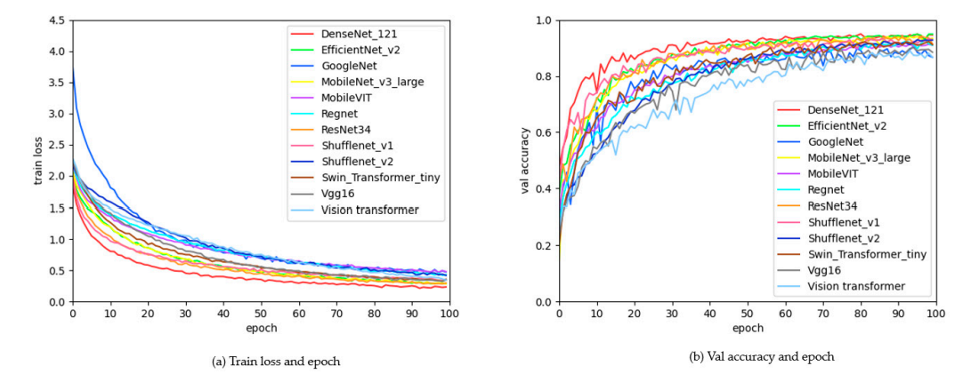

**Data Visualization**

* To make your rice type classification model more transparent and interpretable, **data visualization** plays a key role during both exploration and evaluation phases. Here's how you can integrate it into *GrainPalette*:
* **📊 Data Visualization Strategies**
* **1. Class Distribution Plot**
* **Why:** Check for class imbalance.
* **How:** Use a bar chart to visualize the number of images per rice type.
* **Tool:** matplotlib, seaborn

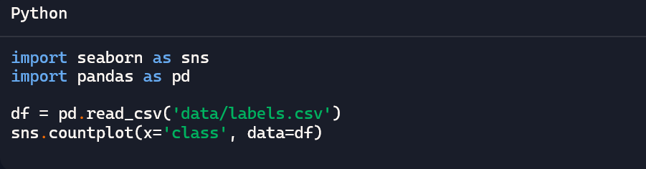

* **2. Sample Image Grid**
* **Why:** Gain intuition about intra-class variability and image quality.
* **How:** Display a few samples per rice type in a grid.
* **Tool:** matplotlib, opencv, PIL
* 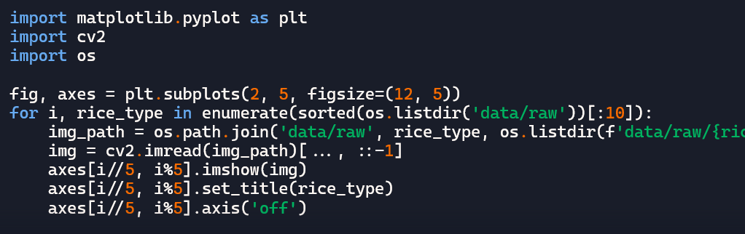**3. Augmentation Preview**
* **Why:** Verify that transformations maintain the rice grain features.
* **How:** Plot original vs. augmented versions side-by-side.
* **Tool:** ImageDataGenerator, albumentations
* **4. Training Metrics Over Epochs**
* **Why:** Visualize model learning progress.
* **How:** Plot training/validation accuracy and loss curves.
* **Tool:** matplotlib, training logs from Keras or PyTorch
* **5. Confusion Matrix**
* **Why:** Understand specific misclassifications.
* **How:** Plot using seaborn.heatmap or sklearn.metrics.confusion_matrix.
* Annotate with actual vs. predicted labels for interpretability.
* If you'd like, I can help generate these plots from your data or build a live dashboard for model inspection using **Streamlit** or **Gradio**. Want to explore that next?

**Split Data and Model Building**

Here’s a practical guide for **splitting the dataset and building the model** for your *GrainPalette* rice type classification project:

**🔀 Data Splitting**

**Objective:** Prepare data subsets that maintain class balance and ensure fair evaluation.

**Steps:**

1. **Organize data folders (if not already):**

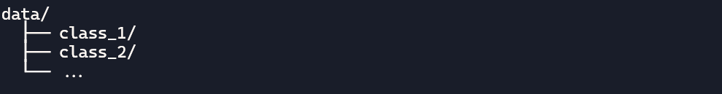

1. **Use stratified splitting to ensure all rice types are evenly represented:**

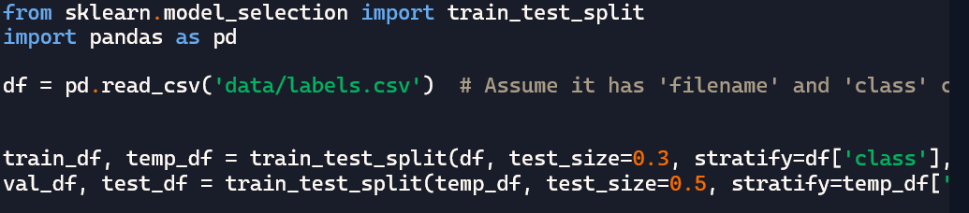

1. **Save splits (optional):**

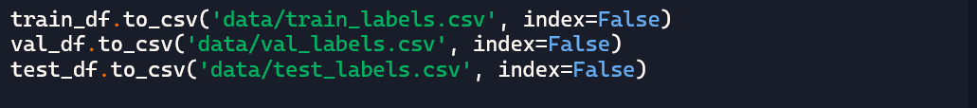

**🧠 Model Building with Transfer Learning**

**Using TensorFlow/Keras with a pre-trained model:**



Once training stabilizes, you can unfreeze some of the deeper layers and fine-tune with a lower learning rate.

**Model Building:**

**Great! Here’s a structured guide to Model Building for your *GrainPalette* rice classification system using transfer learning:**

**🧠 Step-by-Step Model Building Process**

**1. Choose a Pre-trained Backbone  
Pick a lightweight and efficient CNN, such as:**

* **MobileNetV2 (fast and suitable for embedded systems)**
* **EfficientNetB0 (great balance between accuracy and speed)**
* **ResNet50 (powerful, though heavier)**

**2. Load the Pre-trained Model Freeze the convolutional base to preserve learned features:**

**3. Add Custom Classification Head**

**4. Compile the Model**

**5. Train the Model**

**Use callbacks like early stopping and model checkpoints:**

**6. Fine-Tune (Optional but Powerful)  
Unfreeze a few top layers of the base model and retrain with a lower learning rate to improve accuracy.**

**Testing Model & Data Prediction**

**To thoroughly test your *GrainPalette* model and integrate data prediction into your workflow, here’s how you can go beyond basic testing and make your model inference-ready:**

**🧪 1. Load the Final Model for Testing**

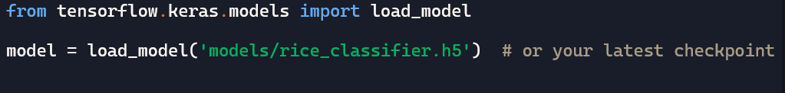

**🖼️ 2. Batch Prediction on Test Set**

**If you're using a test_generator or data from a DataFrame:**



**Generate a classification report:**

**🔍 3. Confusion Matrix Visualization**

**📸 4. Predict on a Single Image**

**Final Project**

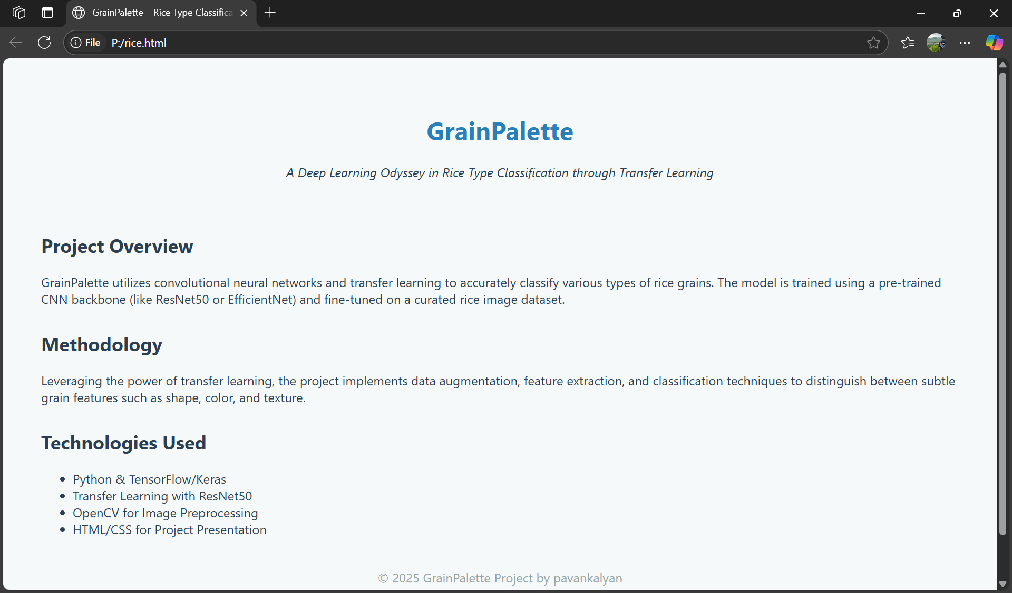

**Prepared by PAVANKALYAN**